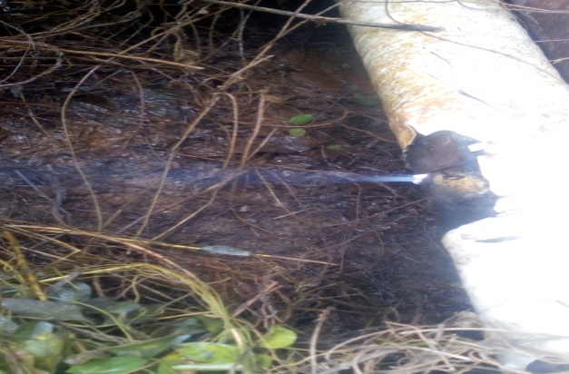
Hack saw cut of about 50mm @ 9-10 o’clock position on the flow line facility

